

**iZZi PGW KT**

**PART-2**

**Document**

**Version1.0**

**Disclaimer**

XIUS Product Services and Features all those defined in this document are configurable and would be enabled based on the mutual agreement between XIUS and the Customer in accordance with the Product License availed by the customer.

**Revision History**

|  |  |  |  |  |  |
| --- | --- | --- | --- | --- | --- |
| **Customer Name** | | iZZi | | | |
| **Document Title** | | iZZi PGW KT Part-2 Document | | | |
| **V. No** | **Start Date** | **Revision Details** | **Author** | **Reviewer** | **Approved by** |
| 1.0 | 13 NOV 2024 | Initial Draft | Tech Publications |  |  |

Table of Contents

1 Introduction 6

1.1 Rating Group ID’s 6

1.1.1 Charging IDs 6

1.2 Create Rating groups in PGW 8

1.3 Create a Service Rule Group 10

1.3.1 Create a service charging Rating Group 11

2 Procedure to modify DNS IP in PGW server 12

3 Enable pcap TRACES and Debug logs by IMSI 14

3.1 Enable pcap TRACES by specific IMSI 14

3.2 Enable Debug file by specific IMSI 15

3.3 Enable or Disable a Debug file in PGW 17

4 Access data from the tech support file 21

5 Login to a particular server in the PuTTY environment 22

5.1 Login to the First server 22

5.2 Login to the Third server 24

6 APN Configuration 25

7 KVM server Reboot 27

8 Microsoft Ticketing Tool 28

9 Workflow in EMS (Element Management System) 29

9.1 Logging In 29

9.2 Home Screen 30

9.2.1 Network View 30

9.2.2 Element details 30

9.2.3 Alarms 31

9.2.4 Event Logs 31

9.2.5 PM Dashboard 32

9.2.6 System Availability 34

9.3 List of operations in EMS 34

9.4 Export as a CSV file 41

10 Further Reading 43

# Introduction

This document briefs about the

1. Creation of Rating Group IDs
2. Procedure to modify DNS IP in PGW server
3. Enabling and Disabling pcap Traces and Debug file logs by IMSI
4. Workflow in Element Management System and
5. Documents related to the execution of the respective commands.

## Rating Group ID’s

Each rating group has different charging IDs and for every subscriber the charging IDs are the same.

At present XIUS is providing services for 12 rating groups including the default rating group.

The subscriber can use all the 12 rating groups at a time for the defined applications. The traffic flow of the applications other than the defined applications will come under the default rating group.

### Charging IDs

1. The charging Id for INSTAGRAM rating group is **charging 13 17**.
2. The service data flow for the INSTAGRAM rating group is shown below, it displays the uplink, downlink and service data flow ID of a particular subscriber.

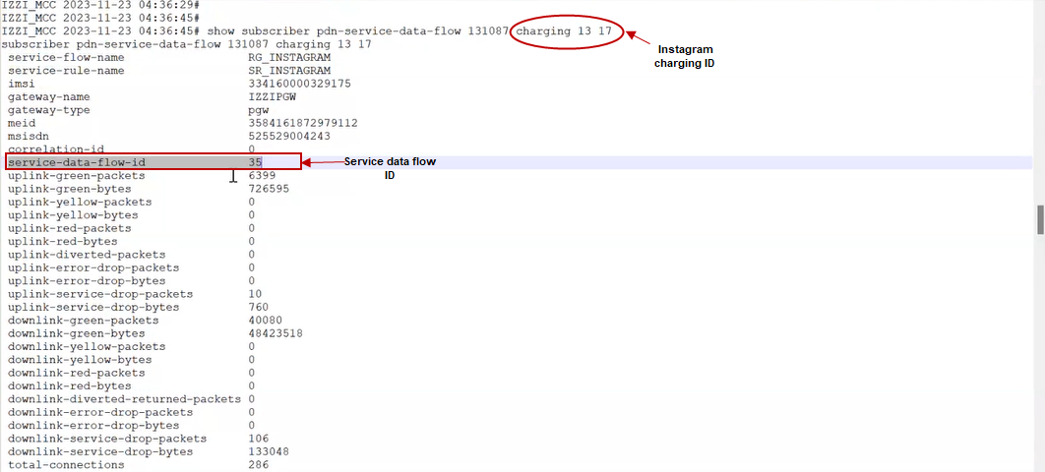

1. The charging id for the default rating group is **charging 2 10**.
2. The service data flow for a default rating group is shown below.

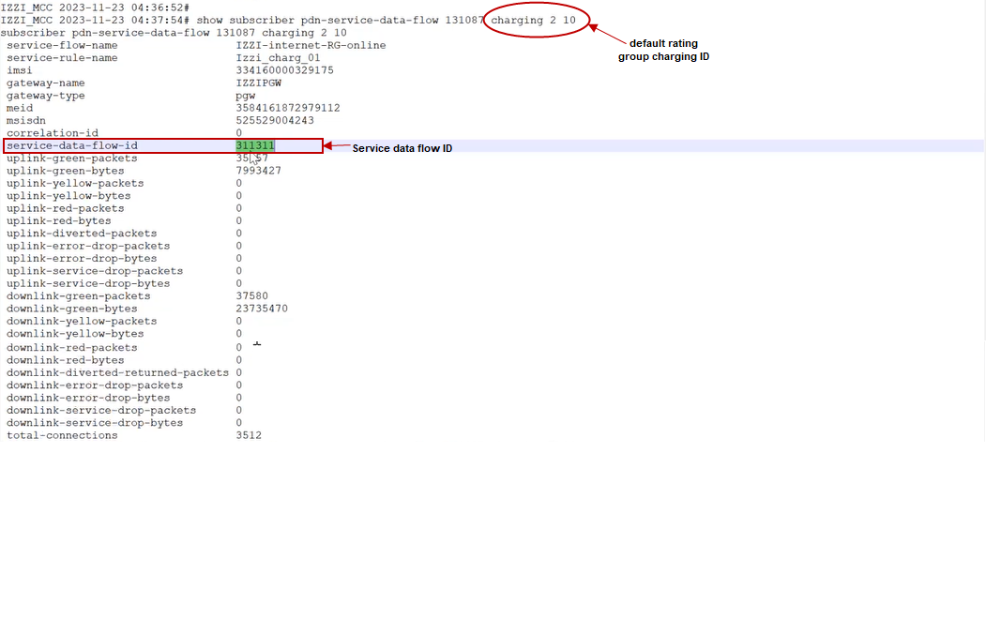

1. The charging ID for the WHATS APP rating group is **charging 9 13.**
2. The service data flow of the WHATS APP rating group is shown below.

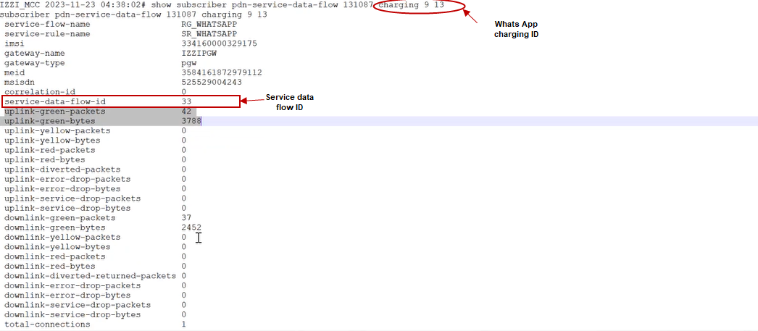

1. The charging ID for the FACEBOOK rating group is **charging 8 9.**
2. The service data flow of the FACEBOOK rating group is shown below.

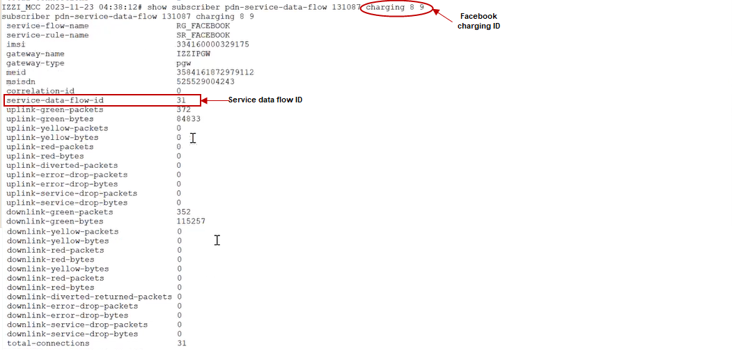

**Note:** *The charging IDs are identical for each subscriber within the rating groups they are assigned to.*

## Create Rating groups in PGW

To create a rating group, follow the below shown steps

1. Take backup for the overall configuration and save the configured file before creating/changing any configuration.
2. To create a **config** mode and configuration mode terminal follow the below shown steps.

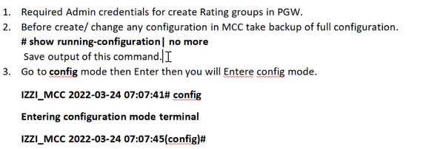

1. To create a protocol application rule group for FACEBOOK, follow the below shown steps.

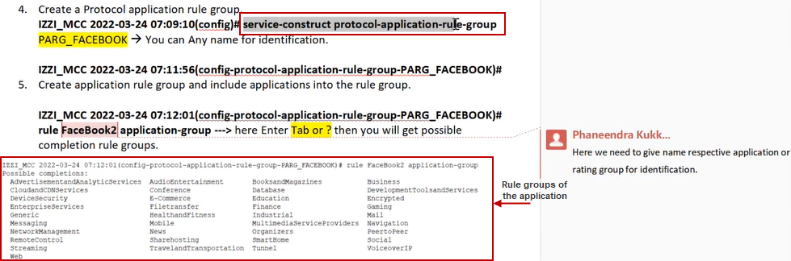

1. Multiple applications available in the rating groups are

* Social
* Streaming
* Business
* Broadband

1. To get the list of social applications for Facebook rule group, follow the below shown step.

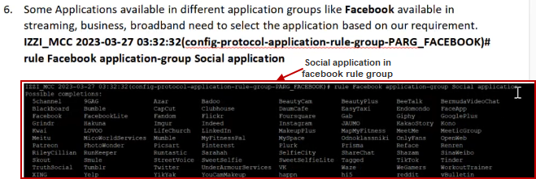

**Note:** *One can create either an application-based rating group with the available application or URL based rating groups.*

1. To create an application rule group for FACEBOOK, follow the below shown steps.

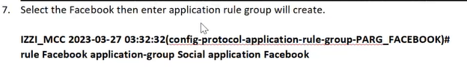

1. To check the configuration and to add multiple applications in a rule group, follow the below shown steps.

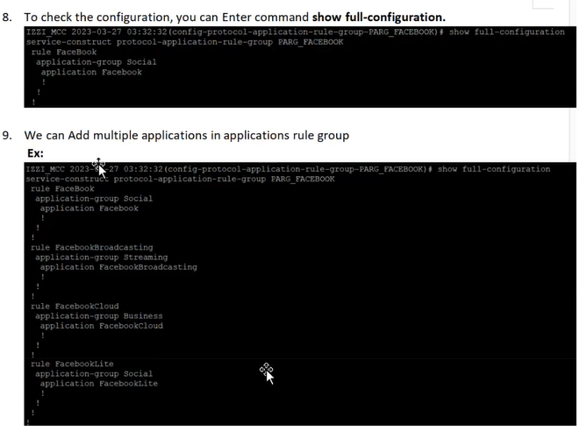

1. To go to the main **config** mode, follow the below step.

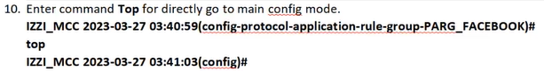

## Create a Service Rule Group

1. To create a service rule group for FACEBOOK, follow the below shown steps.

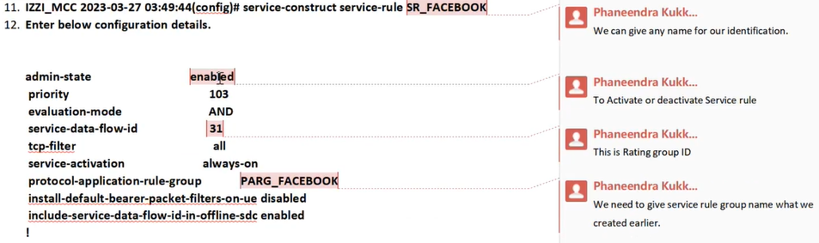

### Create a service charging Rating Group

1. To create a service charging rating group, follow the below shown steps.

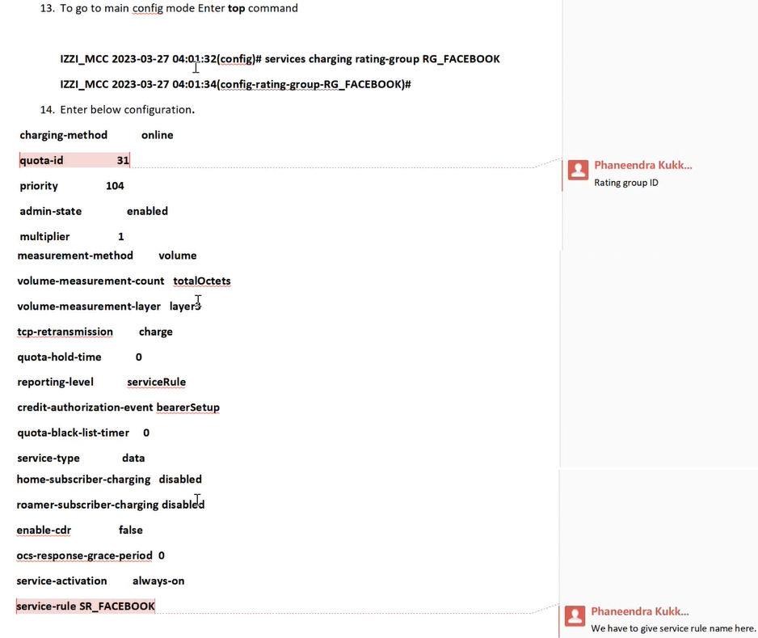

1. To add a rating group into a billing plan, follow the below shown steps.

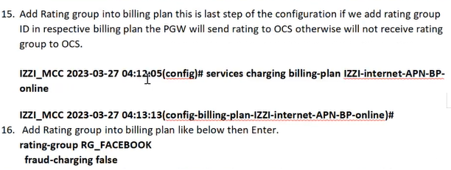

1. After the completion of creating a service rule rating group, follow the below shown steps to check the current changes in the configuration, to store the changes and to exit the **config** mode.

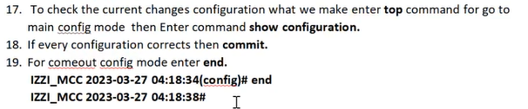

# Procedure to modify DNS IP in PGW server

1. To Login to the MCC cluster with Admin user, to back up the current configuration and to get into the **config** mode, follow the below shown steps.

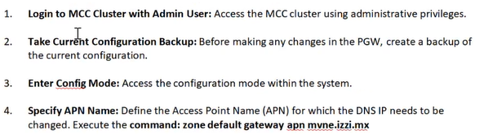

1. We can create/modify DNS IP, based on the APN (Access Point Name). Currently Xius is providing **apn mvne.izzi.mx.**
2. To specify an APN, refer to the below step.



1. To retrieve the current configuration details, enter the below shown command.
2. It displays the configuration available in the **apn** **mvne.izzi.mx.**

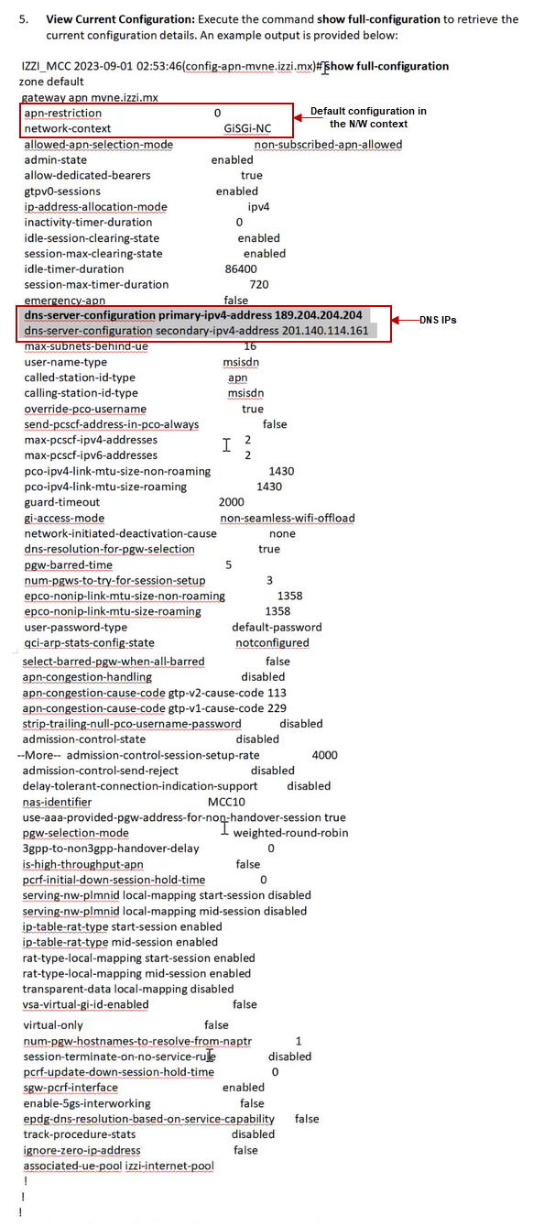

1. To modify the primary address of the DNS server, follow the below shown step.



1. To return to the home **config** mode and to verify the updated changes, follow the below shown steps.

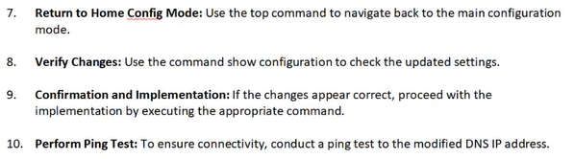

1. To proceed with the implementation and to perform the ping test, follow the below shown steps.

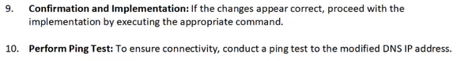

# Enable pcap TRACES and Debug logs by IMSI

Whenever a customer raises a ticket, the affirmed team will get the traces and debug log information for troubleshooting.

## Enable pcap TRACES by specific IMSI

To enable control plane TRACES, follow the below shown procedure.

1. Admin privileges are required to enter the **configuration** mode for every configuration change.
2. Multiple IMSIs can be added under the same policy name.
3. To enable the pcap Traces for the specific IMSI, configure the parameters as shown below.

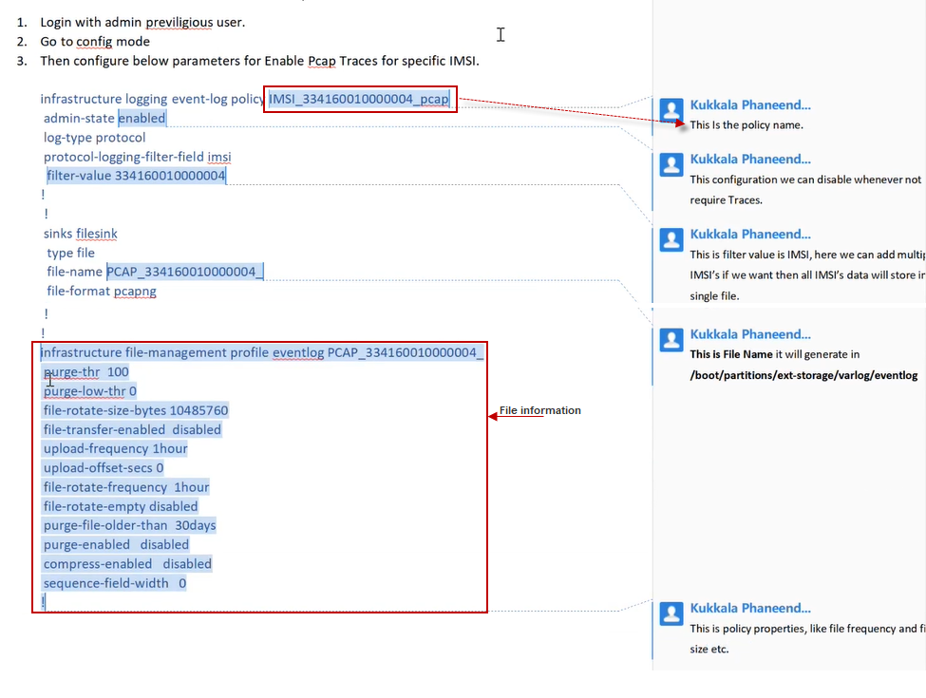

**Note:** *This configuration can be enabled or disabled at any time.*

1. After enabling the Traces, follow the below shown steps to go to the home **config** mode, to check the configuration validation and to store the changes.

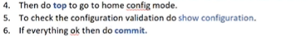

## Enable Debug file by specific IMSI

To enable the debug file, follow the below shown procedure.

1. For every change in the configuration, the admin privileges are needed before getting into the **config** mode.
2. To enable a debug file for the specific IMSI, configure the parameters as shown below.

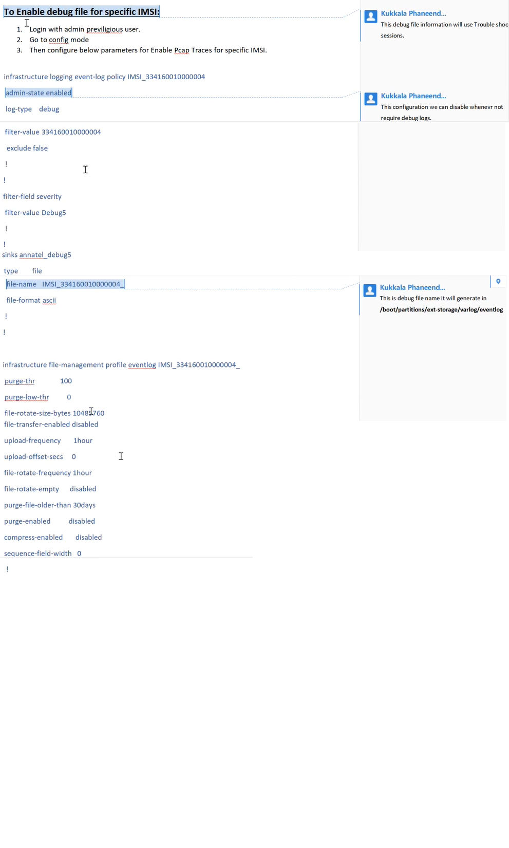

**Note:** *This configuration can be enabled or disabled at any time.*

1. After enabling the debug file, follow the below shown steps to go to the home **config** mode, to check the configuration validation and to store the changes.

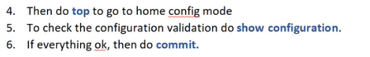

1. To disable the traces or debug files, execute the below shown command and specify **disable** in the admin-state and execute.

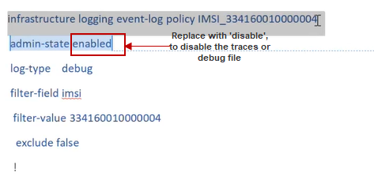

**Note:** *Execute* *the commit command to apply the changes to the configuration.*

## Enable or Disable a Debug file in PGW

1. To enable a debug file in the specific IMSI, enter the below **show** command in PGW.

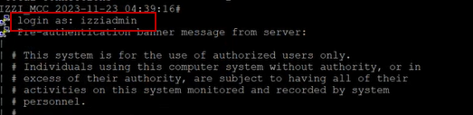

1. Go to **config** mode, as shown below.

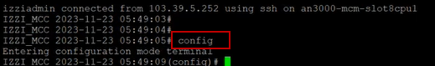

1. To display the list of current policies, execute the below **show** command.



1. Choose a specific policy from the list of current policies and execute the command as shown below.



1. To view the full configuration of the policy, enter the **show** command. It displays the enabled debug file as shown.

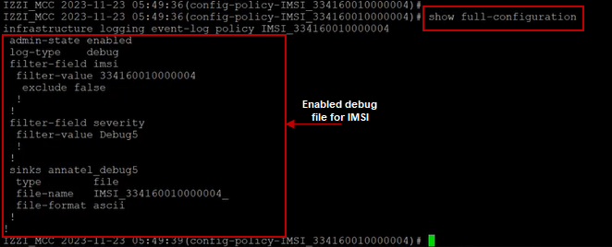

1. To disable the policy, enter the below shown command.

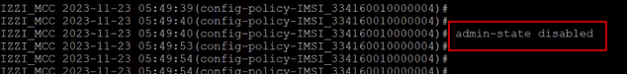

1. To get the full configuration of the disabled policy, enter the **show full-configuration** command. It displays the disabled debug file as shown.

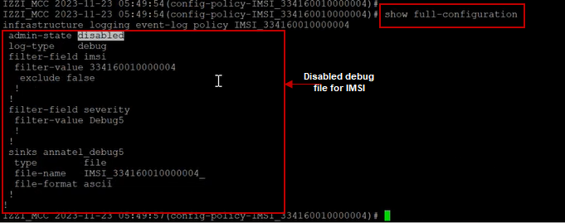

1. Execute the ‘**?**’ command, it displays the list of workflows for the selected policy as shown.

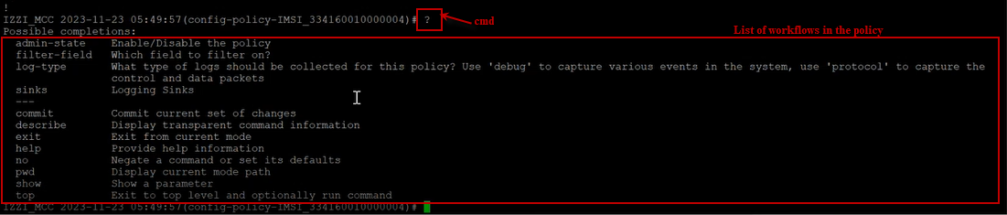

1. To add an IMSI to the same policy, execute the below shown command.



1. Exit from the **Filed value** and **filter field** modes by executing the ‘***exit***’ command as shown below.





1. Execute the ‘**show full-configuration’** command, to confirm the attachment of IMSI to the policy as shown.

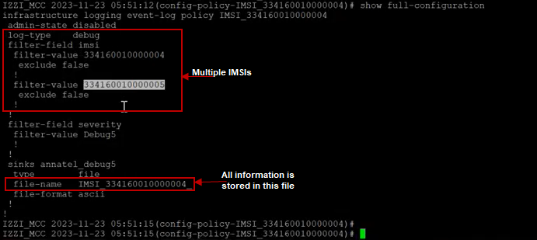

**Note:** *We can create multiple policies or multiple IMSIs for the same policy.*

1. The file is generated in the below shown path.

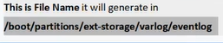

1. To get access to the server path, keep the IP address constant and specifythe port number as **2222** in the **Port number** field as shown below and click on **Login** to get access to the path.

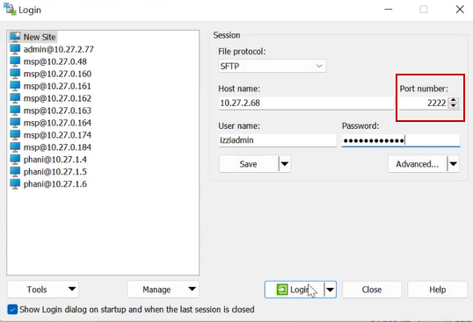

1. All the pcap Traces, Debug files and tos files are displayed, as shown below.

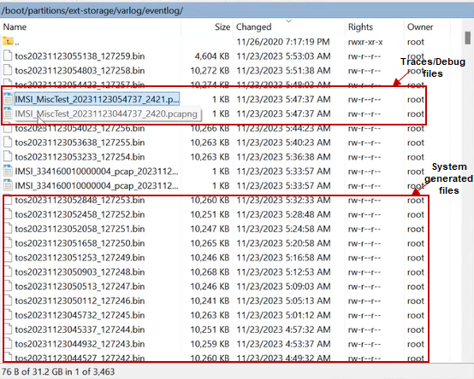

1. tos files are system generated logs, which are used for troubleshooting.

**Note:** *The file occupies the space as defined in the configuration. After exceeding the limit, a new file will be created.*

# Access data from the tech support file

To retrieve information from the tech support file, follow the below shown procedure in PGW.

1. Based on the ticket raised, the Affirmed team/Microsoft team fetches the tech support file along with the details, as shown below.



**Note*:*** *Based on the issue faced date/time specify the numdays/numhours in the execution command to generate the path.*

**For example:** *If the issue is faced yesterday specify the last 2 days / If the issue is faced in last 1 hour specify the last 2 hours.*

1. The tech support file contains the overall information of the application.
2. After executing the command, the tech support file is generated including the file path as shown below.

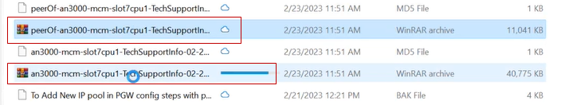

**Note:** *The* ***tech-support-info*** *file generation time depends on the specified number of hours/days.*

**For example:** *It will require at least 15 minutes to generate the tech support file data for one day.*

# Login to a particular server in the PuTTY environment

XIUS has five physical servers, in Part-1 document we have discussed the execution of commands in the MCC VIP cluster ID **10.27.2.68.** This section briefs about the execution of commands in a specific server.

## Login to the First server

1. To perform the execution of commands for the first server get the IP address of the first server from the below shown list.

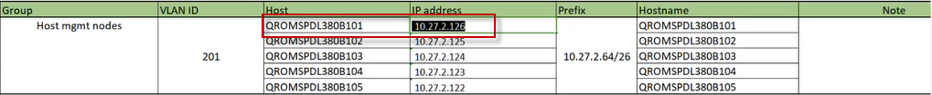

1. Configure a new session in the PuTTY environment to run the application and enter the IP address **10.27.2.126** in the **Host Name/IP address** field, as shown below.

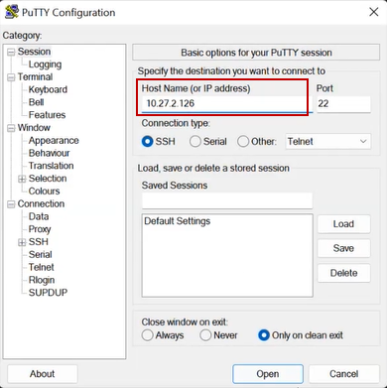

1. Click on **Open.**
2. Enter the Login ID and execute the below shown command to display the list of applications deployed in the first server.

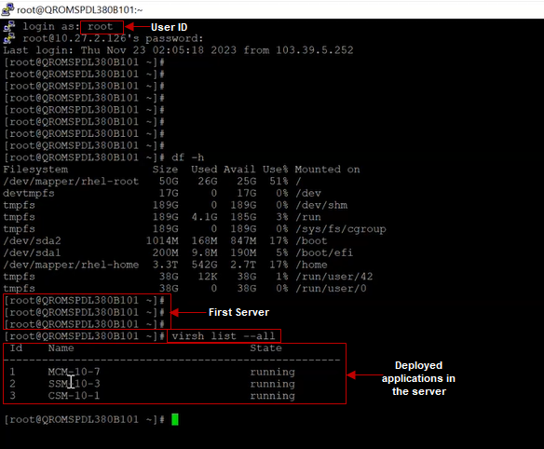

## Login to the Third server

1. To get the list of applications deployed in the third server. Configure a new session to run the application and enter the IP address **10.27.2.124** in the **Host Name/IP address** field, as shown below.

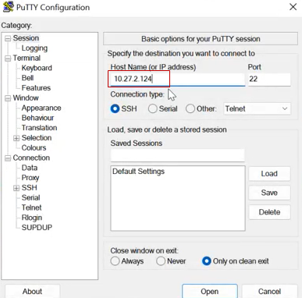

1. Click on **Open**.
2. Enter the Login ID and execute the below shown command to display the list of applications deployed in the third server.

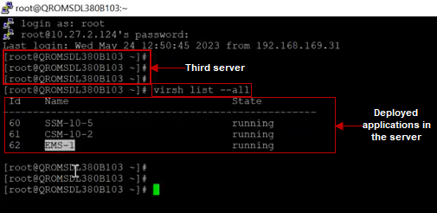

# APN Configuration

Follow the below shown procedure to create a VPN on customer request.

1. To go to the config mode, follow the below shown step.

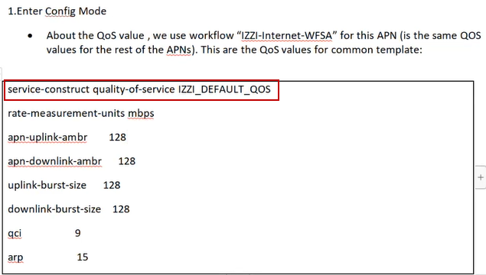

1. Manually execute the below shown commands to create a VPN.

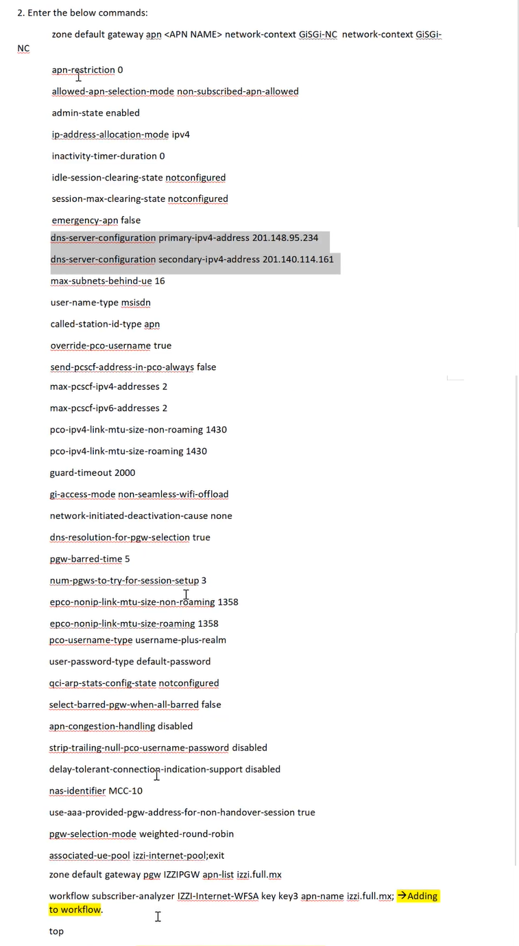

1. To verify the modifications in the configuration and to store the changes, follow the below shown steps.

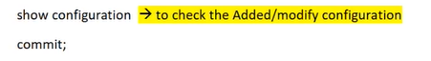

# KVM server Reboot

1. To reboot a specific node or to restart an application, follow the below shown steps.

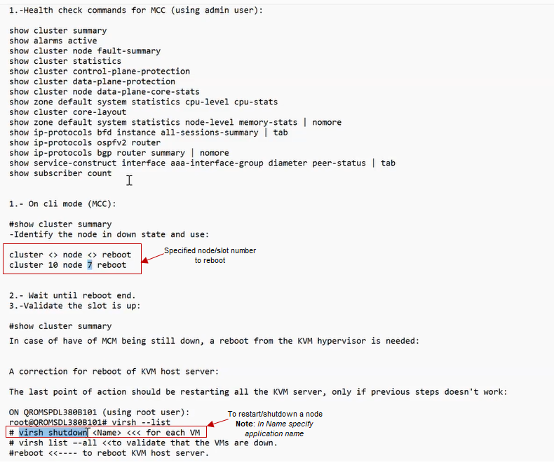

1. To reboot a KVM server, follow the below shown steps.

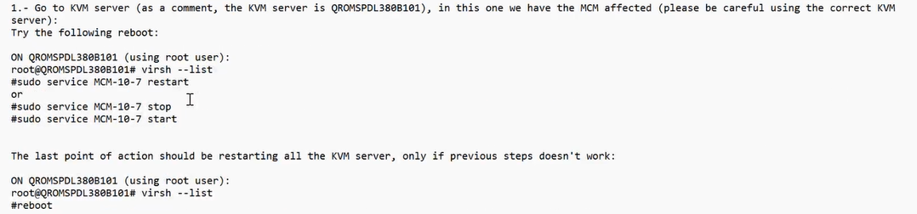

**Note:** *We can restart/shutdown a node either by using the Cluster ID or Server. During this the ID of the node gets changed.*

# Microsoft Ticketing Tool

1. To raise/view a ticket, open the URL of Microsoft ticketing tool and click on **Login**, as shown below.

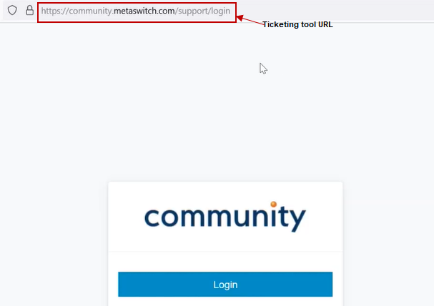

1. Enter the valid user credentials in the username and password field and click on Login, the following home page is displayed.

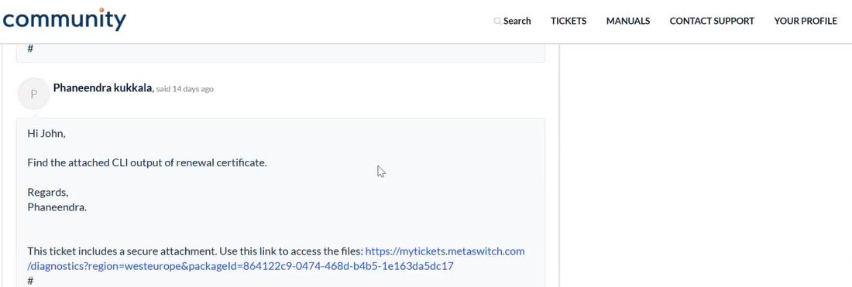

1. Click on **TICKETS** in the menu bar, it displays the record of tickets generated as shown.

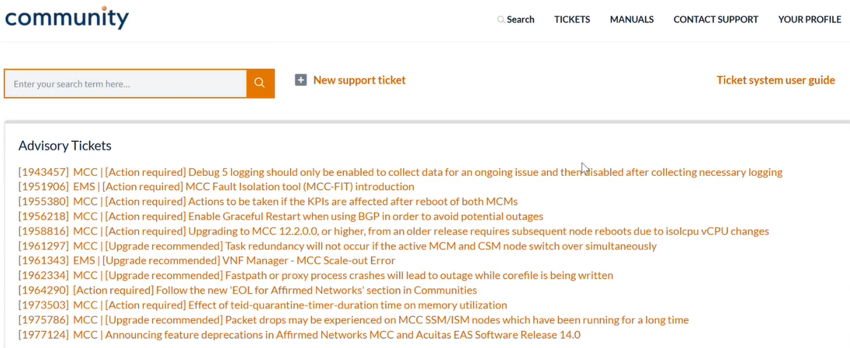

# Workflow in EMS (Element Management System)

## Logging In

1. To login to the EMS (Element Manage System) server, enter the cluster IP address of EMS in the search bar as shown.



1. The login screen is displayed as shown.



1. Enter the valid username in the **Username** field.
2. Enter the password in the **Password** field.
3. Click on **Login**, the following screen is displayed.

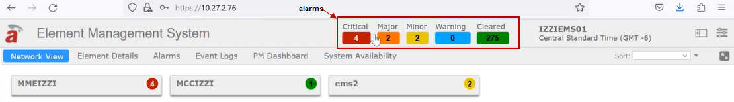

## Home Screen

The home screen of EMS displays the number of Critical, Major, Minor, Warning and Cleared alarms related to MCC and MME.

The EMS home screen includes

* Network View
* Element Details
* Alarms
* Event Logs
* PM Dashboard
* System Availability, as shown



Click on **Critical**, it displays the list of critical alarm details as shown.

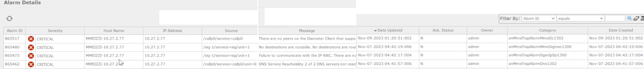

### Network View

Click on **Network View,** it displays the list ofapplications connected to the EMS as shown.

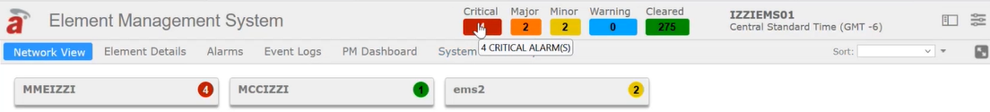

### Element details

Click on **Element details, i**t displays EMS Server details of both MCC and MME as shown.

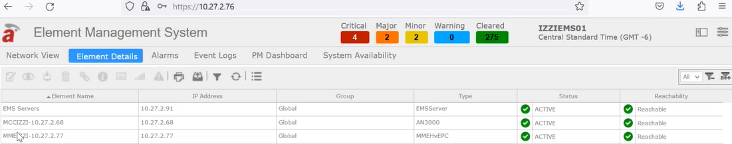

### Alarms

Click on **Alarms**, it displays the list of information related to the status of the alarms as shown.

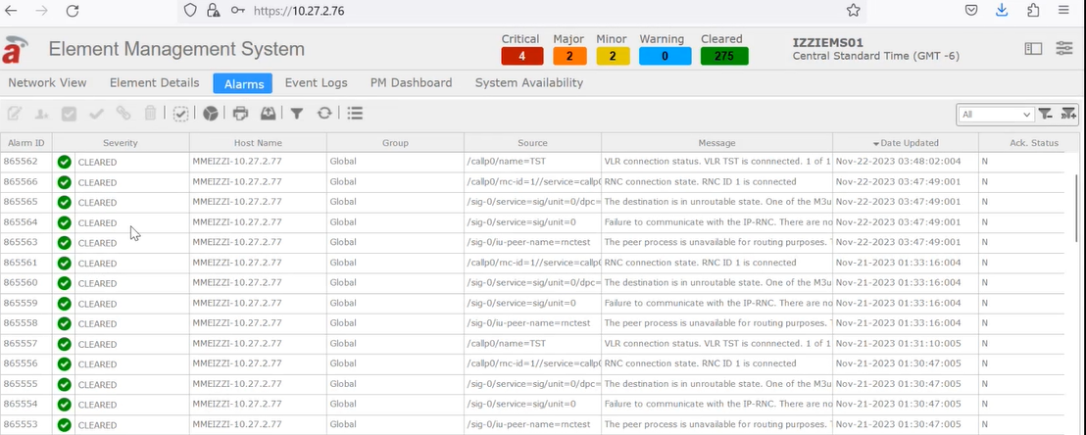

### Event Logs

Click on **Event Logs**, it displays the list of information related to the tickets raised as shown.

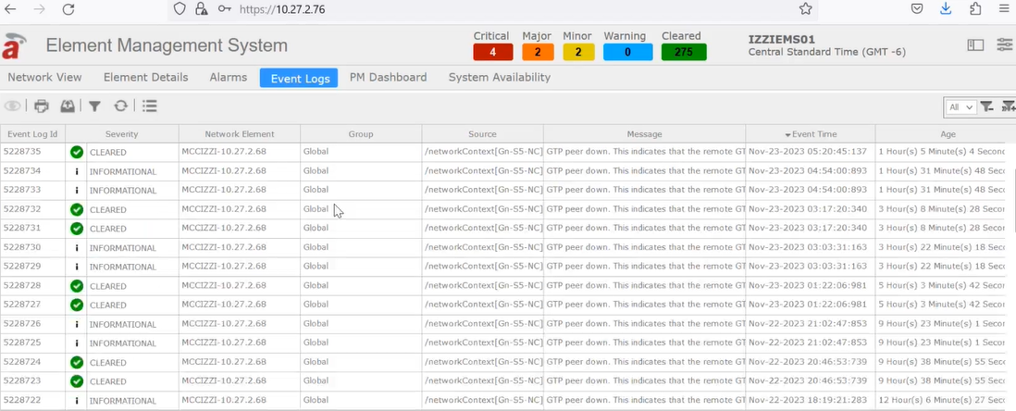

### PM Dashboard

1. Click on **PM Dashboard** and select **Throughput** from the drop-down list as shown.

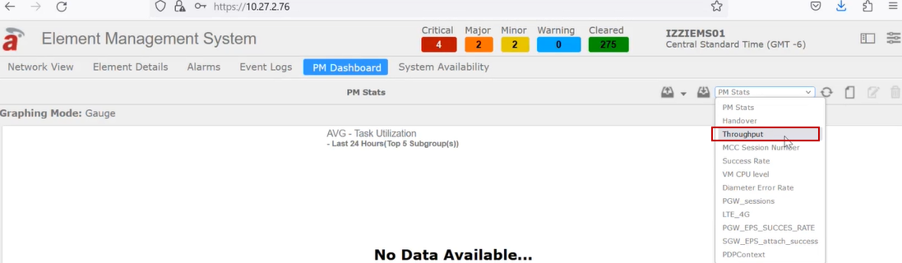

1. It displays the current throughput of uplink and downlink as shown.

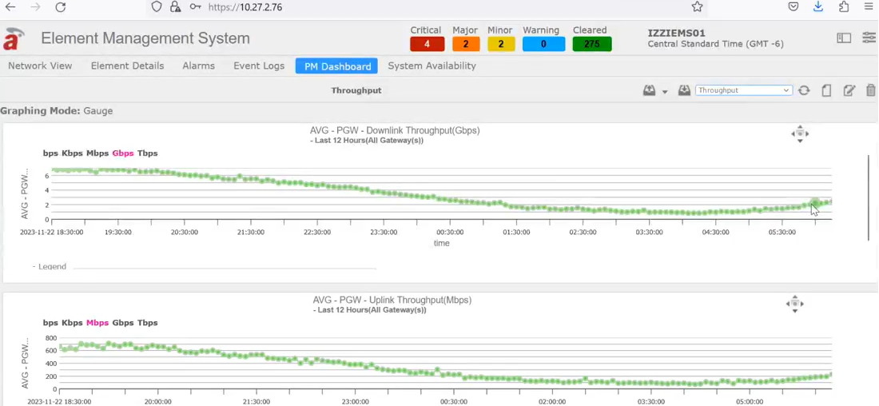

1. Select the **Success Rate** from the dropdown list in the **PM Dashboard** screen as shown.

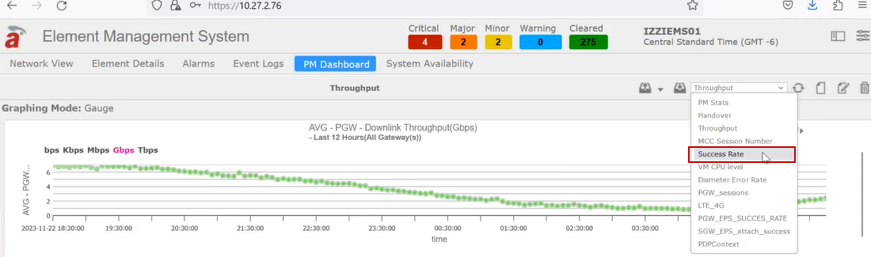

1. It displays the success rate for PDP Context, EPS Bearer Activation and EPS Attach as shown.

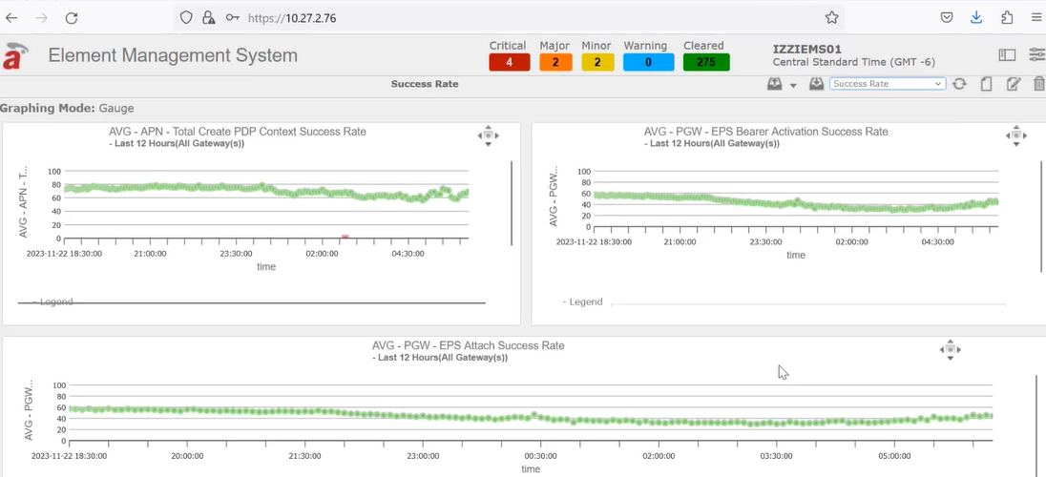

1. Select the **PDPContext** from the dropdown list in the **PM Dashboard** screen as shown.

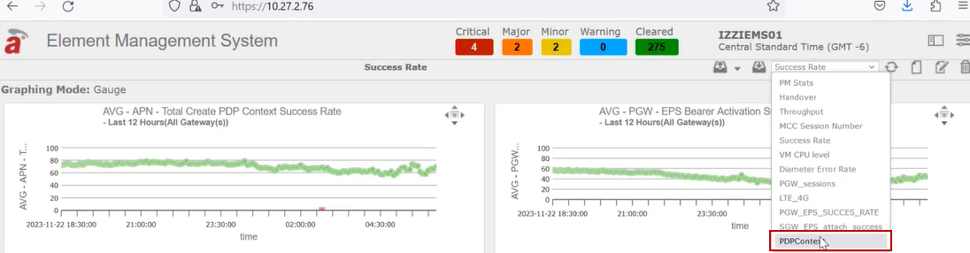

1. It displays the PDP Context success rate as shown.

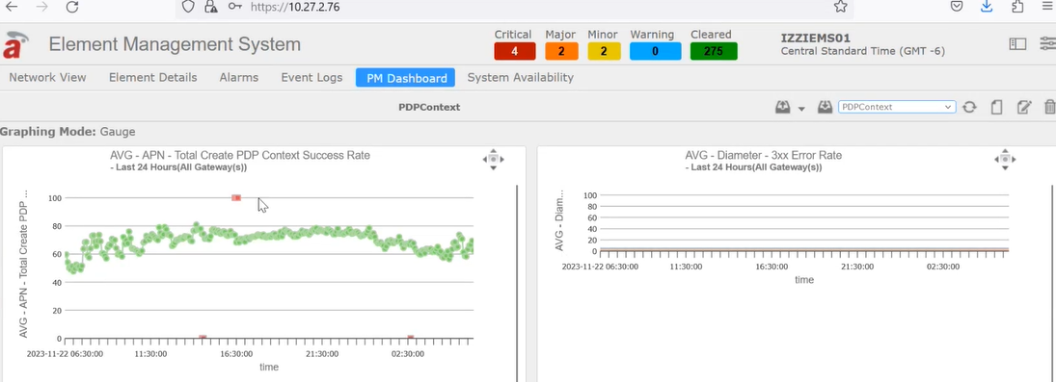

### System Availability

Click on **System Availability**, it displays the status of the system as shown.

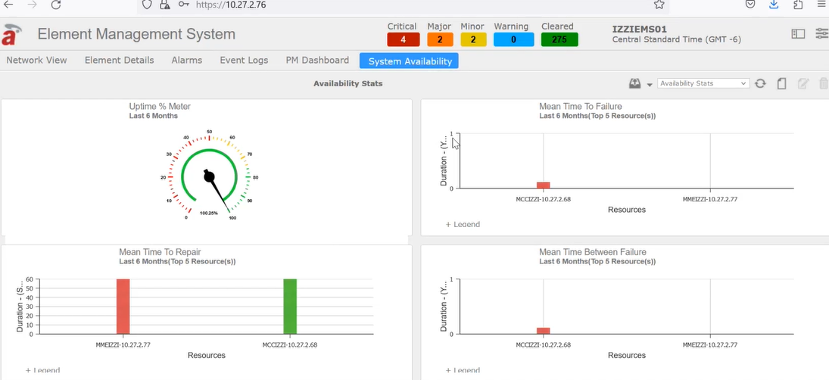

## List of operations in EMS

1. Click on the filter button present in the right end of the EMS home screen, it displays the list of necessary actions as shown.

* Configuration
* Performance
* Security
* Topology
* Fault
* VNF Manager
* Tools
* Help
* About
* Change Theme
* Logout admin

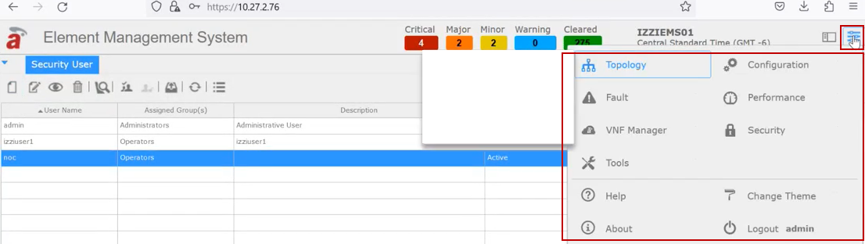

1. To configure the templates, software, files, alarms etc., click on the **Configuration** and the associated fields are displayed as shown.

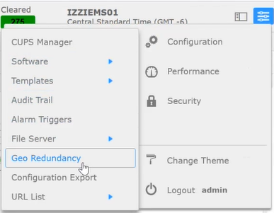

1. To get the history of API Information, click on **Performance** and select **Report Info** and click on **Historical** as shown.

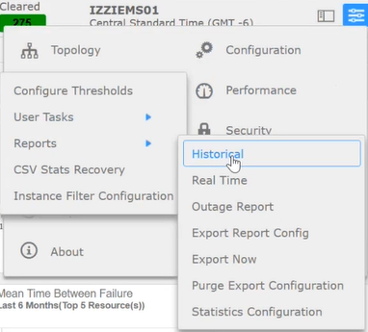

1. It displays the historical statistics of MCC and MME as shown.

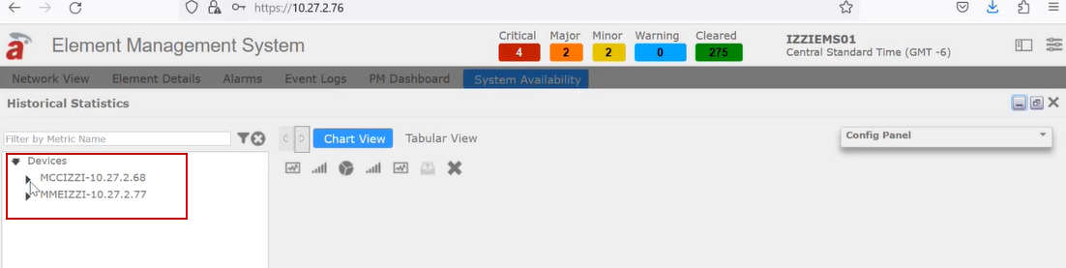

1. Click on MCC IZZI-10.27.2.68 to view the expanded MCC-related statistics. as shown below.

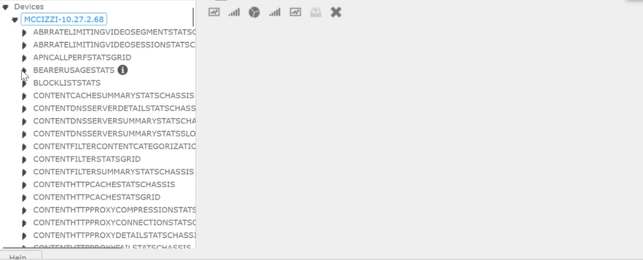

1. To get the graph for the uplink and down link bytes, expand the **BEARERUSAGESTATS** field under the **MCCIZZI-10.27.2.68** and select the check boxes of **totalUplinkbytes** and **totalDownlinkbytes** and click on the **Line chart** icon on the Historical Statistics screen.
2. It auto selects the **default_pgw_IZZIPGW_9** fieldboth inuplink and downlink bytes field and displays the graph for uplink and downlink bytes as shown.

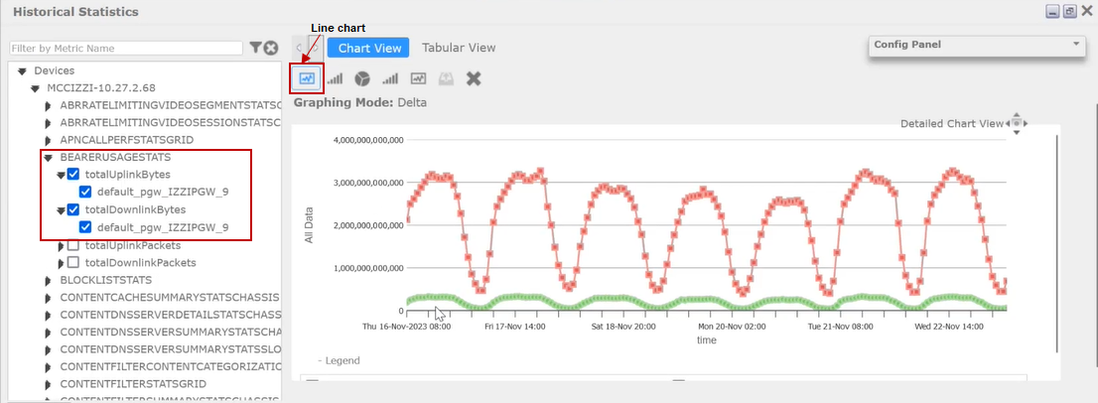

1. Click on the **Detailed chart view**, to display the data for the selected date range as shown.

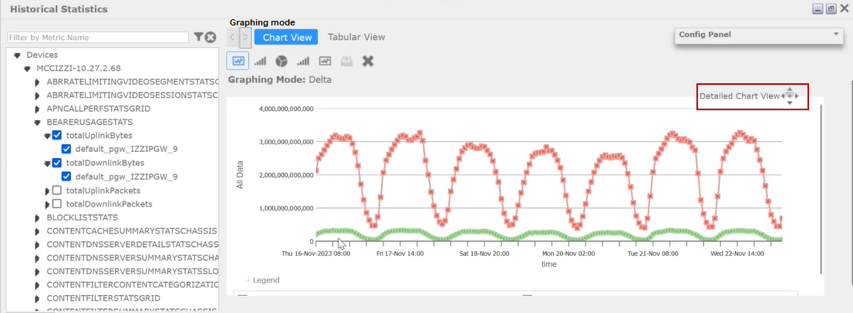

1. Choose the from and to date range from the calendar inthe **From** and **To** fields to get the information of the data for the specific period as shown.

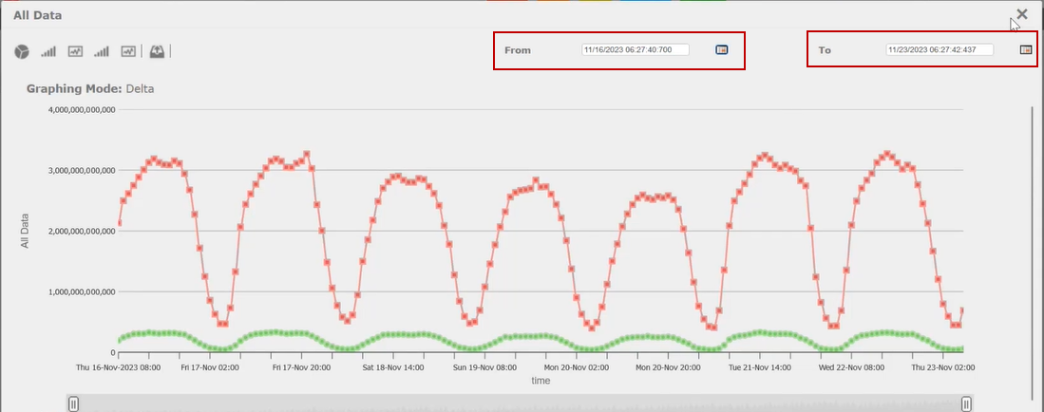

**Note:** *Multiple Historical view statistics are available in both* ***MCCIZZI-10.27.2.68*** *and* ***MMEIZZI-10.27.2.77.***

1. To download the generated image, click on **Export as PDF** icon as shown.

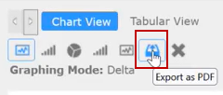

1. Enter the file name in the **PDF File Name** field and click on **Export**, to save the generated file in the local path.

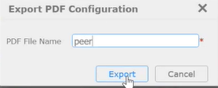

1. To create a user/to manage the user details, click on **Security** and select **User Management** as shown below.

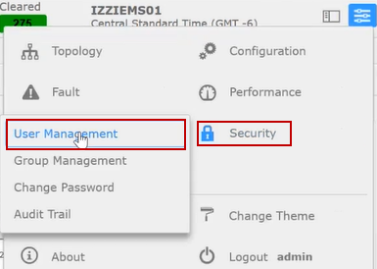

1. It displays the list of users in the EMS as shown.

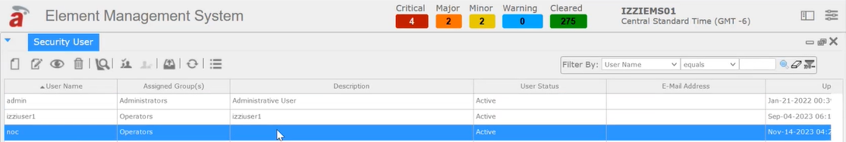

1. To add a new user to the EMS environment, click on the **Add** icon as shown.

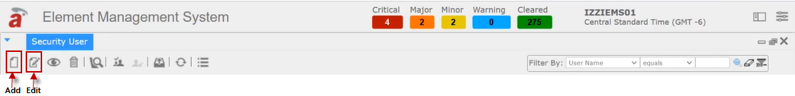

1. The **Add User** screen is displayed as shown.

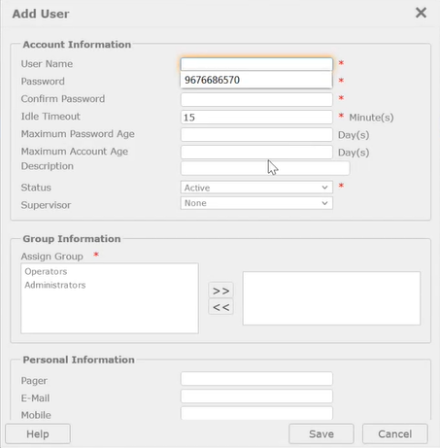

1. For data configuration backup, click on the **Tools** and select **NE Configuration Backup** as shown.

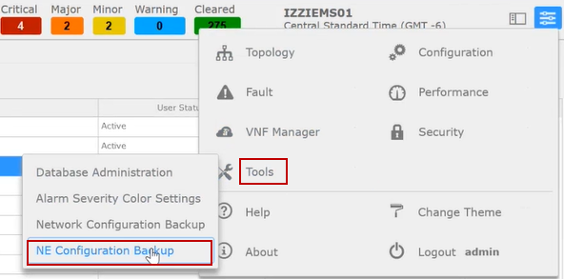

1. To know about the version details of the EMS. click on **Abou**t as shown.

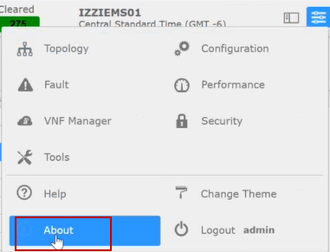

1. It displays the latest released version of the EMS as shown.

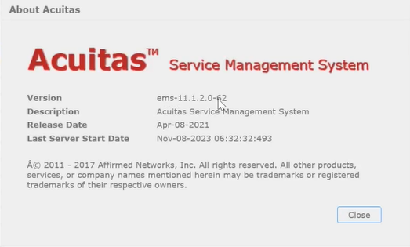

1. To get the list of email ids attached to the EMS, click on the **Fault** then select **Manage** and click on **Email Notifications** as shown.

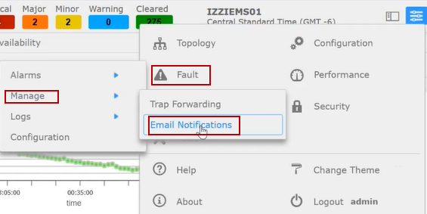

1. It displays the list of email Ids attached to the server as shown.

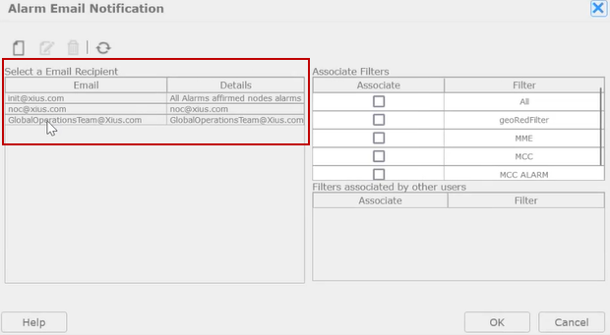

## Export as a CSV file

1. To download as a CSV file, go to the **PM Dashboard** and select **Throughput** from the drop-down list it displays the graph for the uplink and downlink bytes, click on the **Detailed chart view** icon as shown.

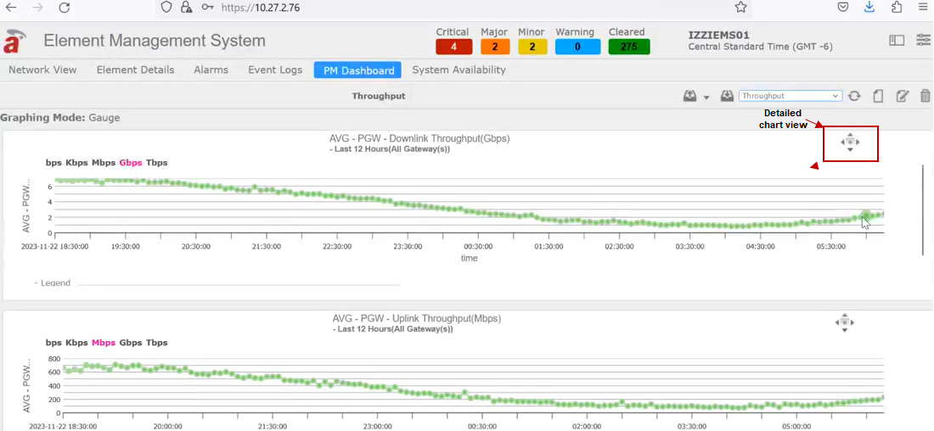

1. It displays the below shown screen, to get the information for a particular duration select the view range in the **View Levels** field and click on **Export as Table CSV** icon as shown.

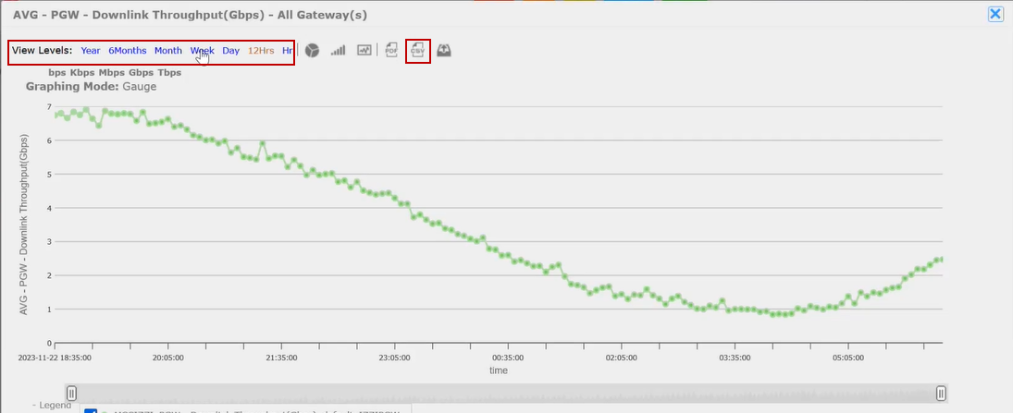

1. The following screen displays, click on the link of the file to download.

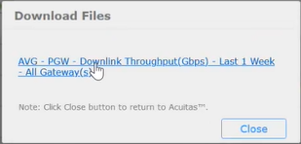

1. It generates a CSV Dash Report as shown.

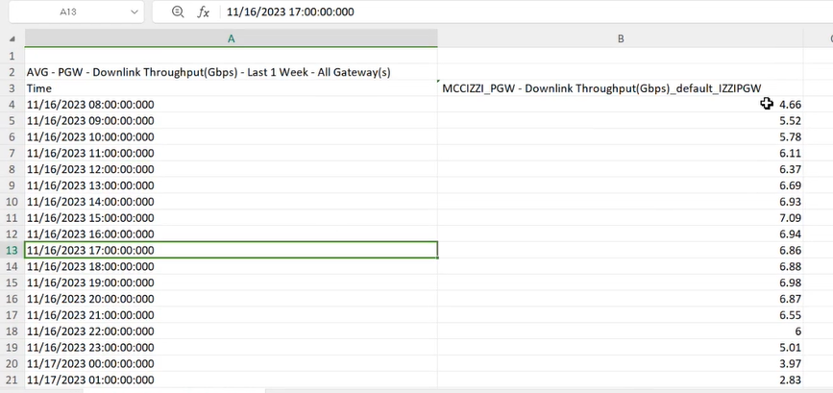

# Further Reading

Refer the following documents related to iZZi PGW command outputs.

|  |  |
| --- | --- |
| **Document Name** | **Link** |
| KVM Statics | [kvm_statics_command outputs.pdf](https://soargtech-my.sharepoint.com/:b:/g/personal/anusha_mohan_xius_com/EQsiHE8N-QBIlBLmY_I-I_ABrJj6RrGV_ZGP7V8IcsMKWQ?e=o1JGfW) |
| MCC Upgradation | [MCC Upgrade.pdf](https://soargtech-my.sharepoint.com/:b:/g/personal/anusha_mohan_xius_com/EeXempgUCHpGpGE5COjYfbUBnZWUncS2RgoQQqSeUztNoA?e=hNMt59) |
| GY Stats | [GY Stats.pdf](https://soargtech-my.sharepoint.com/:b:/g/personal/anusha_mohan_xius_com/EYolwFiZHjtKnTnypFbZGoYBKhzSVkEjwTxxmfQv01PyGg?e=guPlHn) |
| SOS Report Creation | [SOS_Report creation in KVM servers.pdf](https://soargtech-my.sharepoint.com/:b:/g/personal/anusha_mohan_xius_com/EVQ2ya6juAtGqRZ3I1GCHfsB8e8vi9LJLEYKaIdsPRx4Bg?e=VzCWeE) |
| Procedure to detach a session from PGW | [Procedure to detach a session session from PGW.pdf](https://soargtech-my.sharepoint.com/:b:/g/personal/anusha_mohan_xius_com/ETbvc7hI-jFFnHUBP-tcf-kBTEECQqNplJqGCjNExvGJgw?e=HDKPv5) |
| Add New IP Pool | [To Add New IP pool in PGW config steps with pre_post_health_check.pdf](https://soargtech-my.sharepoint.com/:b:/g/personal/anusha_mohan_xius_com/EVAaECSuStdIjsMkuxOXDI0BZbmlwtqogkhcLINU3Nzvkg?e=furRAl) |
| Loop Backup IP Creation | [Loop backup.pdf](https://soargtech-my.sharepoint.com/:b:/g/personal/anusha_mohan_xius_com/EQKxaAWHCINOvz-MJRFScOUBEYIvb7vL1t1T9fhLQMTcSw?e=3LZC59) |